**Simple UI for Score**

**Objective:** In this lesson students will learn how to add a canvas and a text message UI element so that we can start displaying score.

First lets make sure we have the packages installed. look for **TextMesh Pro**. If you don’t have it go to Package Manager and look in Unity Registry for it.

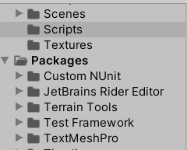

1. Right click in **Hierarchy** go to **UI> Text TextMesh Pro**

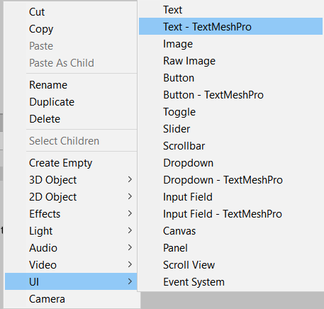

1. Click **Import TMP Essentials**
2. Also **Import Examples and Extras**

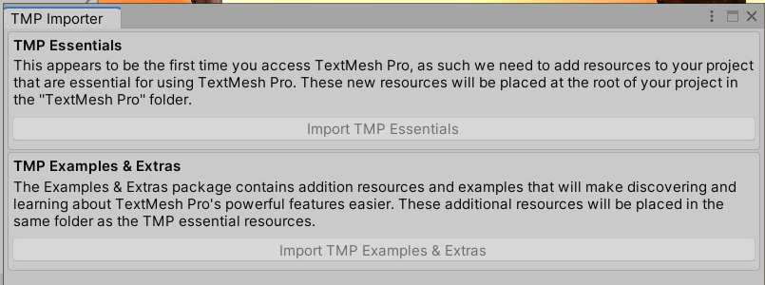

1. In our Hierarchy we should now have the following:

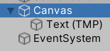

**EventSystem** has to do with buttons so its not a concern right now.

1. The canvas is where we paint our UI. If you click on it it should show the outline. You can’t really move it around. It stays in front of the Camera.

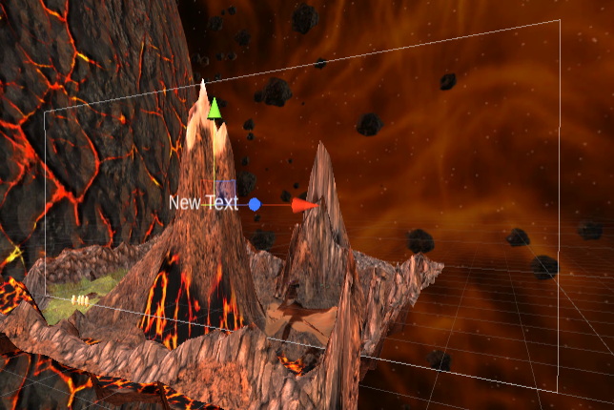

1. If you press Play you should see **New Text**

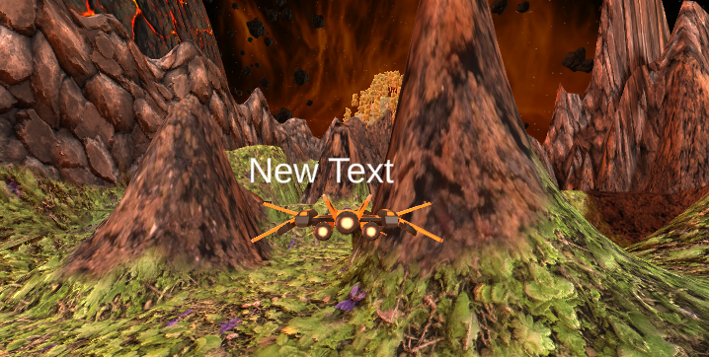

1. Click on the **Canvas** and click on the **2D button** to get a better view

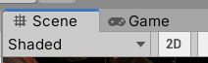

1. Click on the **Text(TMP)** in the Hiearchy and press W to move it around.
2. The flower in the middle is the **anchor point**. The 4 arrows represent where the outside anchor points are. So I’m going to grab 2 opposite corners and place them in their respective corners

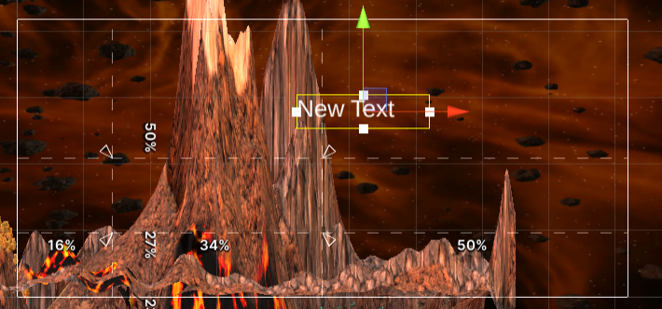

1. Move the **New Text** to the bottom left
2. Feel free to hide your terrain to get a better view
3. Lets find better font. Lets go to [dafont.com](http://www.dafont.com). I looked for **Retro** and found one called **Venus Rising**.
4. Click Download, Extract and Look for the .**rg** file and copy it over to the Assets folder. 
5. Click on **Window> TextMeshPro> Font Asset Creator**
6. Drag the font you chose from the Assets folder to the **Source Font File** field

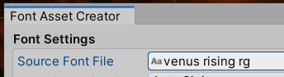

1. Click Generate Font Atlas
2. Click Save As and save inside the TextMesh Pro folder in your Assets.
3. Close the Asset creator
4. Click on Text(TMP) in the hierarchy and look for the Font Asset field



1. Choose your newly created text asset.
2. When it says **New Text** I’m going to replace with **123456789**

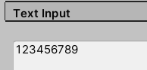

1. I’m going to resize my text box so all the numbers fit on one line

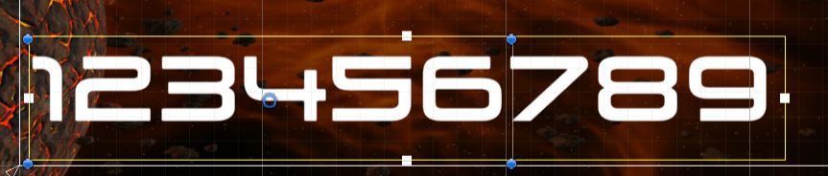

1. You can change the Font Size or Font Style if you want



1. Change the **Vertex Color** to something that pops



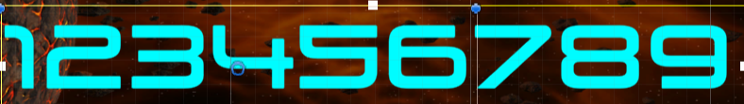

1. Change the Alignment so its in the middle of the box

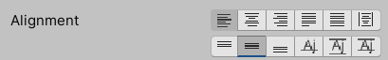

1. Click on the box in the top left

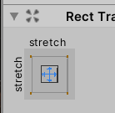

1. Choose Bottom Left so the text is anchored here.

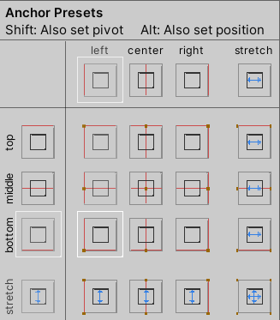

1. That makes it to where no matter how big the screen is the text stays on the bottom left.
2. Now we want our text to resize with our screen so click on **Canvas**
3. Find **Render Mode** make sure its on **Screen Space - Overlay**
   1. **World Space** is if you want to have a user interface like health bar above the player

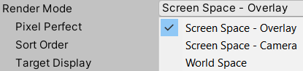

If you had multiple UI you could use **Sort Order** to determine which has priority



1. Find **UI Scale Mode** in the **Canvas Scaler** module and change it to **Scale With Screen Size**



1. Change **Reference Resolution** to 1920x1080



1. Lets change the **font size** to **80** and resize it so it all fits on one line again
2. Rename **Text(TMP)** GameObject to **ScoreBoard**

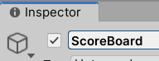

1. Delete the Previous **ScoreBoard** (the one NOT in canvas)
2. Click on the **ScoreBoard**, click **Add Component** and add the **ScoreBoard.cs** script
3. Make a **prefab** out of the **Canvas** GameObject (Make sure it's in your prefab folder)
4. Last lets make a prefab out of **Spawn at Runtime**